**Training model – Test results**

1. **Original training data – unbalanced data**
2. **Training model: Random forest – 47 images (36 train 11 test)**
   1. **ntree = 200**

|  |  |  |  |  |
| --- | --- | --- | --- | --- |
|  | **Precision** | **Precision recall** | **F1-score** | **Accuracy**  **(P = 1)** |
| TP/predicted P | TP/actual yes |  | (TP+TN)/total |
| Morphology features | 0.59091 | 0.36932 | 0.45455 | 0.9148 |
| SURF | 0.72603 | 0.30114 | 0.4257 | 0.9219 |
| BRISK | 0.73016 | 0.26136 | 0.38494 | 0.9198 |
| HOG | 0.83784 | 0.35227 | 0.496 | 0.9312 |
| FREAK | 0.67164 | 0.25568 | 0.37037 | 0.9165 |
| Morphology + SURF | 0.79167 | 0.32386 | 0.45968 | 0.9269 |
| Morphology  + SURF + BRISK | 0.89063 | 0.32386 | 0.475 | 0.9312 |
| Morphology + SURF + BRISK + HOG + FREAK | 0.83784 | 0.35227 | 0.496 | 0.9312 |

* 1. **ntree = 600**

|  |  |  |  |  |
| --- | --- | --- | --- | --- |
|  | **Precision** | **Precision recall** | **F1-score** | **Accuracy**  **(P = 1)** |
| TP/predicted P | TP/actual yes |  | (TP+TN)/total |
| Morphology features | 0.57282 | 0.33523 | 0.42294 | 0.9121 |
| SURF | 0.74648 | 0.30114 | 0.42915 | 0.923 |
| BRISK | 0.73771 | 0.25568 | 0.37975 | 0.9198 |
| HOG | 0.84722 | 0.34659 | 0.49194 | 0.9312 |
| FREAK | 0.73771 | 0.25568 | 0.37975 | 0.9198 |
| Morphology + SURF | 0.82609 | 0.32386 | 0.46531 | 0.9285 |
| Morphology  + SURF + BRISK | 0.83077 | 0.30682 | 0.44813 | 0.9274 |
| Morphology + SURF + BRISK + HOG + FREAK | 0.86567 | 0.32955 | 0.47737 | 0.9307 |

1. **Training model: SVM – 47 images (36 train 11 test)**

|  |  |  |  |  |  |  |
| --- | --- | --- | --- | --- | --- | --- |
|  | **Cost** | **Gamma** | **Precision** | **Precision recall** | **F1-score** | **Accuracy**  **(P = 1)** |
| TP/predicted P | TP/actual yes |  | (TP+TN)/total |
| Morphology features |  |  |  |  |  |  |
| SURF |  |  |  |  |  |  |
| BRISK |  |  |  |  |  |  |
| HOG |  |  |  |  |  |  |
| FREAK |  |  |  |  |  |  |
| Morphology + SURF |  |  |  |  |  |  |
| Morphology  + SURF  + BRISK |  |  |  |  |  |  |
| Morphology + SURF  + BRISK  + HOG  + FREAK |  |  |  |  |  |  |

1. **Oversampling data**
2. **Random Forest** 
   1. **ntree = 200**

|  |  |  |  |  |
| --- | --- | --- | --- | --- |
|  | **Precision** | **Precision recall** | **F1-score** | **Accuracy**  **(P = 1)** |
| TP/predicted P | TP/actual yes |  | (TP+TN)/total |
| Morphology features | 0.90216 | 0.42874 | 0.58125 | 0.6911 |
| SURF | 0.98545 | 0.32729 | 0.49139 | 0.6612 |
| BRISK | 0.96038 | 0.30737 | 0.46569 | 0.6473 |
| HOG | 0.97876 | 0.36172 | 0.52822 | 0.6769 |
| FREAK | 0.95825 | 0.27717 | 0.42998 | 0.6325 |
| Morphology + SURF | 0.98793 | 0.34601 | 0.51252 | 0.6709 |
| Morphology  + SURF + BRISK | 0.98674 | 0.31461 | 0.47711 | 0.6552 |
| Morphology + SURF + BRISK + HOG + FREAK | 0.98618 | 0.34481 | 0.51096 | 0.67 |

* 1. **ntree = 600**

|  |  |  |  |  |
| --- | --- | --- | --- | --- |
|  | **Precision** | **Precision recall** | **F1-score** | **Accuracy**  **(P = 1)** |
| TP/predicted P | TP/actual yes |  | (TP+TN)/total |
| Morphology features | 0.90675 | 0.44626 | 0.59814 | 0.7002 |
| SURF | 0.98692 | 0.31884 | 0.48197 | 0.6573 |
| BRISK | 0.9661 | 0.30978 | 0.46914 | 0.6495 |
| HOG | 0.98374 | 0.36534 | 0.53281 | 0.6796 |
| FREAK | 0.96617 | 0.31039 | 0.46984 | 0.6498 |
| Morphology + SURF | 0.98459 | 0.34722 | 0.51339 | 0.6709 |
| Morphology  + SURF + BRISK | 0.9911 | 0.33635 | 0.50225 | 0.6667 |
| Morphology + SURF + BRISK + HOG + FREAK | 0.983 | 0.34964 | 0.51581 | 0.6718 |

1. **SVM**

|  |  |  |  |  |  |  |
| --- | --- | --- | --- | --- | --- | --- |
|  | **Cost** | **Gamma** | **Precision** | **Precision recall** | **F1-score** | **Accuracy**  **(P = 1)** |
| TP/predicted P | TP/actual yes |  | (TP+TN)/total |
| Morphology features | *1* | *0.1428571* | *0.7173* | *0.83213* | *0.7704* | *0.7521* |
| 10 | 0.01 | 0.68276 | 0.87077 | 0.76539 | 0.7331 |
| SURF | *1* | *0.1428571* | *0.7173* | *0.83213* | *0.7704* | *0.7521* |
| 1 | 0.001 | 0.77563 | 0.7035 | 0.73781 | 0.75 |
| BRISK | *1* | *0.01515152* | *0.86859* | *0.49094* | *0.627314* | *0.7083* |
| 0.1 | 0.1 | 0.693998 | 0.782 | 0.73538 | 0.7186 |
| HOG | *1* | *0.02631579* | *0.84543* | *0.65399* | *0.73749* | *0.7672* |
| 0.1 | 0.1 | 0.77905 | 0.74094 | 0.75952 | 0.7654 |
| FREAK | *1* | *0.01515152* | *0.86859* | *0.49094* | *0.627315* | *0.7083* |
| 0.1 | 0.1 | 0.6940 | 0.7820 | 0.73538 | 0.7186 |
| Morphology + SURF | *1* | *0.01408* | *0.89264* | *0.54227* | *0.54227* | *0.7385* |
| 0.1 | 0.1 | 0.67432 | 0.79771 | 0.73084 | 0.7062 |
| Morphology  + SURF  + BRISK | *1* | *0.007407407* | *0.9080* | *0.50121* | *0.64591* | *0.7252* |
| 0.1 | 0.001 | 0.76448 | 0.70954 | 0.73598 | 0.7455 |
| Morphology + SURF  + BRISK  + HOG  + FREAK | *1* | *0.004255319* | *0.91847* | *0.53744* | *0.6781* | *0.7449* |
| 0.1 | 0.01 | 0.76452 | 0.71558 | 0.7392 | 0.7476 |

**Note:**

**1.**

|  |  |  |  |
| --- | --- | --- | --- |
| n = total | **Actual: NO** | **Actual: YES** |  |
| **Predicted: NO** | TN | FN | TN+FN |
| **Predicted: YES** | FP | TP | FP+TP |
|  | N = TN+FP | P = FN+TP |  |

1. **Precision (Pos Pred Value):** When it predicts yes, how often is it correct? **TP/predicted: YES**

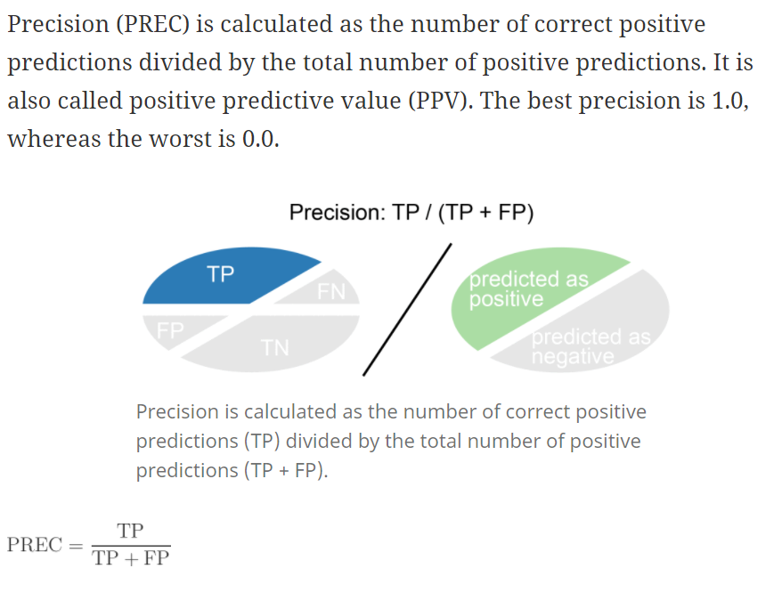

1. **Precision recall (Sensitivity/True Positive Rate):**

When it's actually yes, how often does it predict yes? **TP/actual: YES**

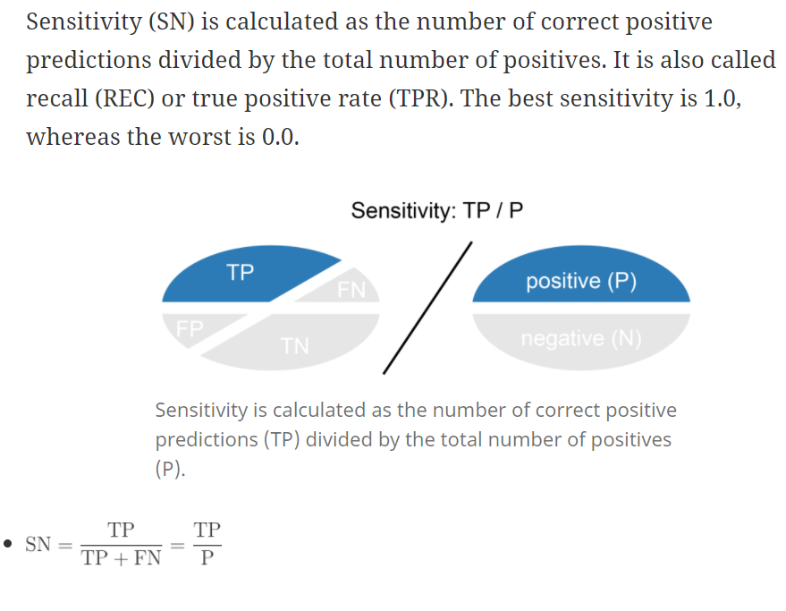

1. **F-score:** This is a weighted average of the true positive rate (recall) and precision.

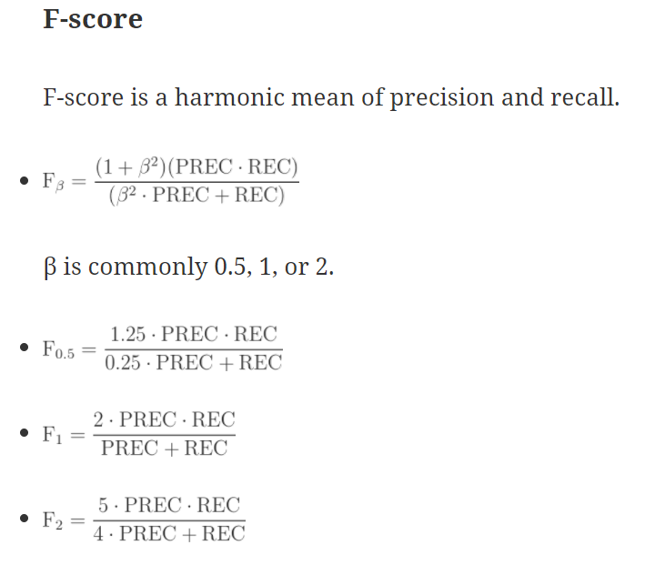

1. **Accuracy:** Overall, how often is the classifier correct? **(TP+TN)/total**

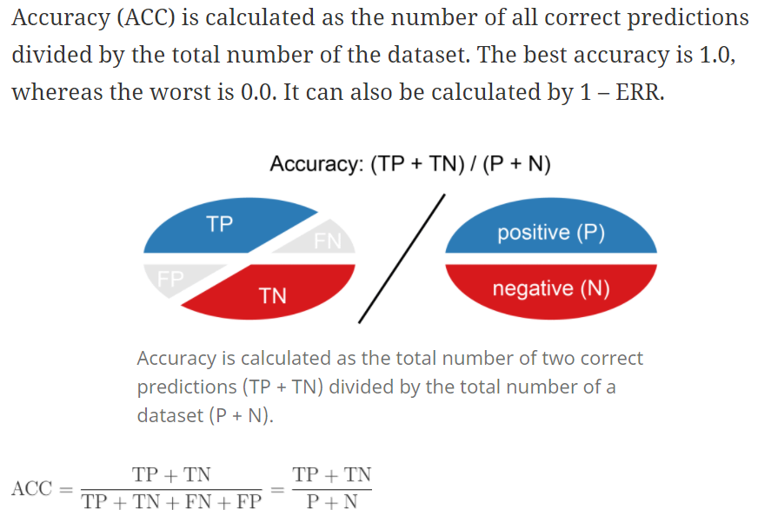

**output <- X[,c("X","Y","isLandmark",colnames(a),colnames(output1)[1],colnames(output1)[2],colnames(output1)[3],colnames(output1)[4], "SURFfeature1","SURFfeature2","SURFfeature3","SURFfeature4","SURFfeature5","SURFfeature6","SURFfeature7","SURFfeature8","SURFfeature9","SURFfeature10","SURFfeature11","SURFfeature12","SURFfeature13","SURFfeature14","SURFfeature15","SURFfeature16","SURFfeature17","SURFfeature18","SURFfeature19","SURFfeature20","SURFfeature21","SURFfeature22","SURFfeature23","SURFfeature24","SURFfeature25","SURFfeature26","SURFfeature27","SURFfeature28","SURFfeature29","SURFfeature30","SURFfeature31","SURFfeature32","SURFfeature33","SURFfeature34","SURFfeature35","SURFfeature36","SURFfeature37","SURFfeature38","SURFfeature39","SURFfeature40","SURFfeature41","SURFfeature42","SURFfeature43","SURFfeature44","SURFfeature45","SURFfeature46","SURFfeature47","SURFfeature48","SURFfeature49","SURFfeature50","SURFfeature51","SURFfeature52","SURFfeature53","SURFfeature54","SURFfeature55","SURFfeature56","SURFfeature57","SURFfeature58","SURFfeature59","SURFfeature60","SURFfeature61","SURFfeature62","SURFfeature63","SURFfeature64", "BRISKfeature1","BRISKfeature2","BRISKfeature3","BRISKfeature4","BRISKfeature5","BRISKfeature6","BRISKfeature7","BRISKfeature8","BRISKfeature9","BRISKfeature10","BRISKfeature11","BRISKfeature12","BRISKfeature13","BRISKfeature14","BRISKfeature15","BRISKfeature16","BRISKfeature17","BRISKfeature18","BRISKfeature19","BRISKfeature20","BRISKfeature21","BRISKfeature22","BRISKfeature23","BRISKfeature24","BRISKfeature25","BRISKfeature26","BRISKfeature27","BRISKfeature28","BRISKfeature29","BRISKfeature30","BRISKfeature31","BRISKfeature32","BRISKfeature33","BRISKfeature34","BRISKfeature35","BRISKfeature36","BRISKfeature37","BRISKfeature38","BRISKfeature39","BRISKfeature40","BRISKfeature41","BRISKfeature42","BRISKfeature43","BRISKfeature44","BRISKfeature45","BRISKfeature46","BRISKfeature47","BRISKfeature48","BRISKfeature49","BRISKfeature50","BRISKfeature51","BRISKfeature52","BRISKfeature53","BRISKfeature54","BRISKfeature55","BRISKfeature56","BRISKfeature57","BRISKfeature58","BRISKfeature59","BRISKfeature60","BRISKfeature61","BRISKfeature62","BRISKfeature63","BRISKfeature64")]**